**SQL With Clause**

# With Clause [CTE / SQF]

**Common Table Expression / Sub Query Factoring**

**Whenever we are using the with clause, it should be before the select statement.**

**Syntax: with alias_name (list_of_columns) as (query) select * from table where clause.**

**The query inside the with clause is executed first and then the data is stored in temp memory / table and that can be referenced by alias.**

**The temp table is not actually temp table, its kindof and its scope is until execution of query.**

# Fetch employees who earn more than average salary of all employees.

**with average_salary (avg_sal) as**

**(select cast (avg(salary) as int) from employee)**

**select \***

**from employee e, average_salary av**

**where e.salary > av.avg_sal;**

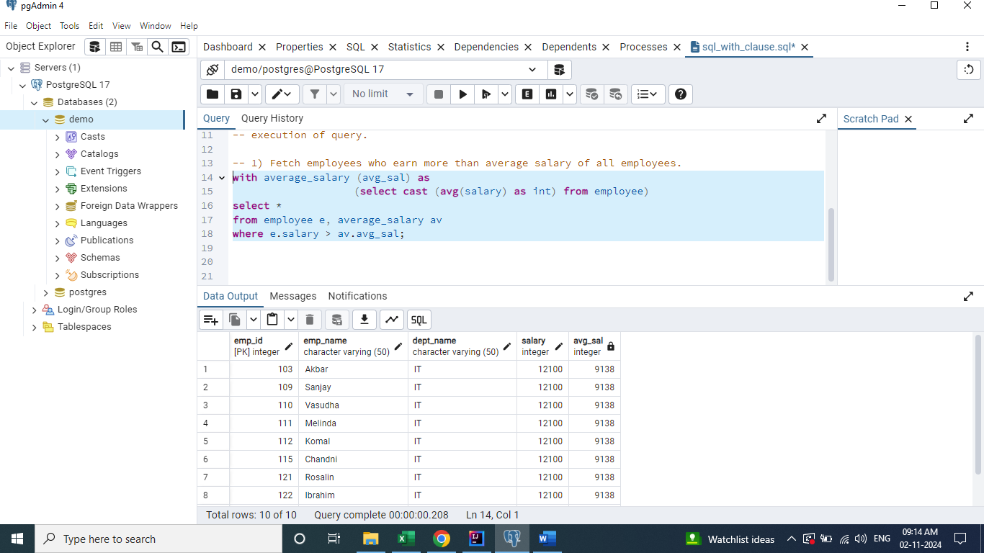

# Find stores who's sales where better than the average sales across all stores.

**with Total_Sales (store_id, total_sales_per_store)**

**as (select s.store_id, sum(s.price * s.quantity) as total_sales_per_store**

**from sales s**

**group by s.store_id),**

**Avg_Sales (avg_sales_for_all_stores)**

**as (select cast( avg(total_sales_per_store) as int) as avg_sales_for_all_stores**

**from Total_Sales)**

**select \***

**from Total_Sales ts**

**join Avg_Sales avs**

**on ts.total_sales_per_store > avs.avg_sales_for_all_stores;**

